Bahria University,

Karachi Campus



LAB EXPERIMENT NO.

_______9_______

LIST OF TASKS

|  |  |
| --- | --- |
| TASK NO | OBJECTIVE |
| 1 | **Create an application named DebugConsole having given UI** |
| 2 | **Create an application which can send broadcast to the DebugConsole (above application).** |

Submitted On:

___________

(Date: 23/5/23)

**LAB # 09**

**Task #1: Create an application named DebugConsole having the following UI:**

**Code:**

**MainActivity Class:**

public class MainActivity extends AppCompatActivity {

    private DebugBroadcastReceiver debugReceiver;

    private TextView debugTextView;

    @Override

    protected void onCreate(Bundle savedInstanceState) {

        super.onCreate(savedInstanceState);

        setContentView(R.layout.activity_main);

        debugTextView = findViewById(R.id.debugTextView);

        debugTextView.setMovementMethod(new ScrollingMovementMethod());

        debugReceiver = new DebugBroadcastReceiver(debugTextView);

        IntentFilter intentFilter = new IntentFilter("DEBUG_INFO");

        registerReceiver(debugReceiver, intentFilter);    }}

DebugBroadcastReceiver Class:

public class DebugBroadcastReceiver extends BroadcastReceiver {

    private TextView debugTextView;

    public DebugBroadcastReceiver(TextView debugTextView) {

        this.debugTextView = debugTextView;

    }

    @Override

    public void onReceive(Context context, Intent intent) {

        if (intent.getAction() != null && intent.getAction().equals("DEBUG_INFO")) {

            String date = intent.getStringExtra("date");

            String appName=intent.getStringExtra("appName");

            String time=intent.getStringExtra("time");

            String message = intent.getStringExtra("message");

            String text = date+" "+appName+" "+time+"\t"+ message +"\n";

            debugTextView.append(text);}    }}

**Output:**

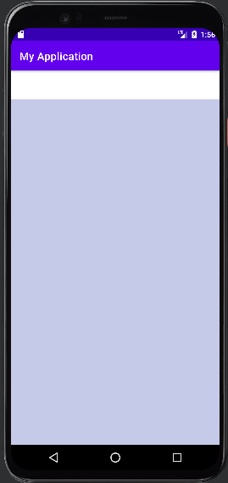

**Task #2: Create an application which can send broadcast to the DebugConsole (above application). You may use the following UI as reference:**

**Code:**

**MainActivity.java:**

public class MainActivity extends AppCompatActivity {

    private EditText messageEditText;  private Button sendButton;   private TextView textView;

    @Override

    protected void onCreate(Bundle savedInstanceState) {

        super.onCreate(savedInstanceState);

        setContentView(R.layout.activity_main);

        messageEditText = findViewById(R.id.editTextTextPersonName);

        sendButton = findViewById(R.id.button);

        textView=findViewById(R.id.textView);

        sendButton.setOnClickListener(new View.OnClickListener() {

            @Override

            public void onClick(View v) {

                String message = messageEditText.getText().toString();

                Date currentTime = new Date();

                SimpleDateFormat timeFormat = new SimpleDateFormat("HH:mm:ss");

                String formattedTime = timeFormat.format(currentTime);

                System.out.println("Current time: " + formattedTime);

                Date currentDate = new Date();

                SimpleDateFormat dateFormat = new SimpleDateFormat("yyyy-MM-dd");

                String formattedDate = dateFormat.format(currentDate);

                System.out.println("Current date: " + formattedDate);             messageEditText.setText("");

                textView.setText("Message Sent");           Intent intent = new Intent("DEBUG_INFO");

                intent.putExtra("message", message);

                intent.putExtra("date", formattedDate);

                intent.putExtra("time", formattedTime);          intent.putExtra("appName", "My Application");               sendBroadcast(intent);     }   });  }}

**Output:**

